BRAUN
Shelly Power Logger
Hardware Description Document • v1.0

Portable 230 V power logger
Shelly Plug S MTR Gen3 + ESP32-WROOM-32 + DS3231 RTC + MicroSD

Author: Jan Pfrang
jan.pfrang@delonghigroup.com
Date: May 28 2026

1. System Overview
The BRAUN Shelly Power Logger is a portable, self-contained instrument for measuring and recording the power consumption of 230 V / 16 A appliances. It requires no external Wi-Fi router or internet connectivity — the entire system forms its own local network.

1.1 Architecture
The system consists of three physical units:
- Shelly Plug S MTR Gen3 — CE-marked smart plug measuring voltage, current, and active power at ~1 Hz. Runs a custom script (shelly_push.js) that pushes JSON measurements over Wi-Fi to the ESP32 every second.
- ESP32-WROOM-32 — acts as the Wi-Fi access point (softAP), web server, RAM buffer, SD card writer, and real-time clock host. Serves a browser-based dashboard over HTTP.
- DS3231 ZS042 RTC module — provides accurate wall-clock timestamps for log entries, connected via I²C.

1.2 Data flow
Shelly script (shelly_push.js) → POST /api/shelly_push → ShellyClient::ingest() → Logger::pollIfDue() → RAM ring buffer → SD card (CSV)

1.3 Key specifications
Parameter | Value
Mains supply | 230 V AC, 50 Hz
Max load current | 16 A (3680 W)
Measurement cadence | 1 s (default); adjustable 1 / 2 / 5 / 10 / 30 s
SD flush interval | Every 10 s
RAM buffer depth | 64 samples (~64 s reserve)
Log format | CSV: time_ms, voltage_V, power_W, pf_apparent
Wi-Fi | 802.11 b/g/n softAP — SSID: PZEM_Logger
Web interface | http://192.168.4.1 or http://braun_PZEM.local
RTC accuracy | DS3231 ±2 ppm (±63 s/year)
LED: 1 Hz blink | System healthy
LED: 5 Hz blink | Error (Shelly silent > 3 s, or SD fault)

2. Component List
Component | Description | Notes
Shelly Plug S MTR Gen3 | Smart plug, 230 V / 16 A, built-in energy meter | CE-marked; shelly_push.js installed
ESP32-WROOM-32 | Dual-core 240 MHz, 4 MB flash, Wi-Fi + BT | Arduino framework
DS3231 ZS042 module | I²C RTC, TCXO-compensated, CR2032 backup | Address 0x68; see battery note
MicroSD card | FAT32-formatted, any capacity | Writes CSV log.csv
230 V → 5 V PSU | Mains-rated isolated supply, ≥ 500 mA | Must be safety-certified
Status LED | Single LED + current-limiting resistor | Connected to GPIO 32
Reset button | Tactile pushbutton | GPIO 33, INPUT_PULLUP (future use)
Balancing resistors | 2 × 100 kΩ | For 2S supercap stack (optional)

2.1 Complete Circuit Schematic
The schematic below shows the complete wiring of the logger. The LED circuit is active-HIGH configuration: GPIO 32 sources current through R3 (220 Ω) and the LED to GND, matching the firmware logic in StatusLed.h.
WRONG IN SCHEMATIC:
P33 (SW1) is connected to GND via a push button – shown as capacitor in the schematic
R1 is 180 kΩ
R2 is 47 kΩ
C1 = C2 = 1F
NTC is 10Ω while cold
3.3 V rail (green and black) need to be connected with each other
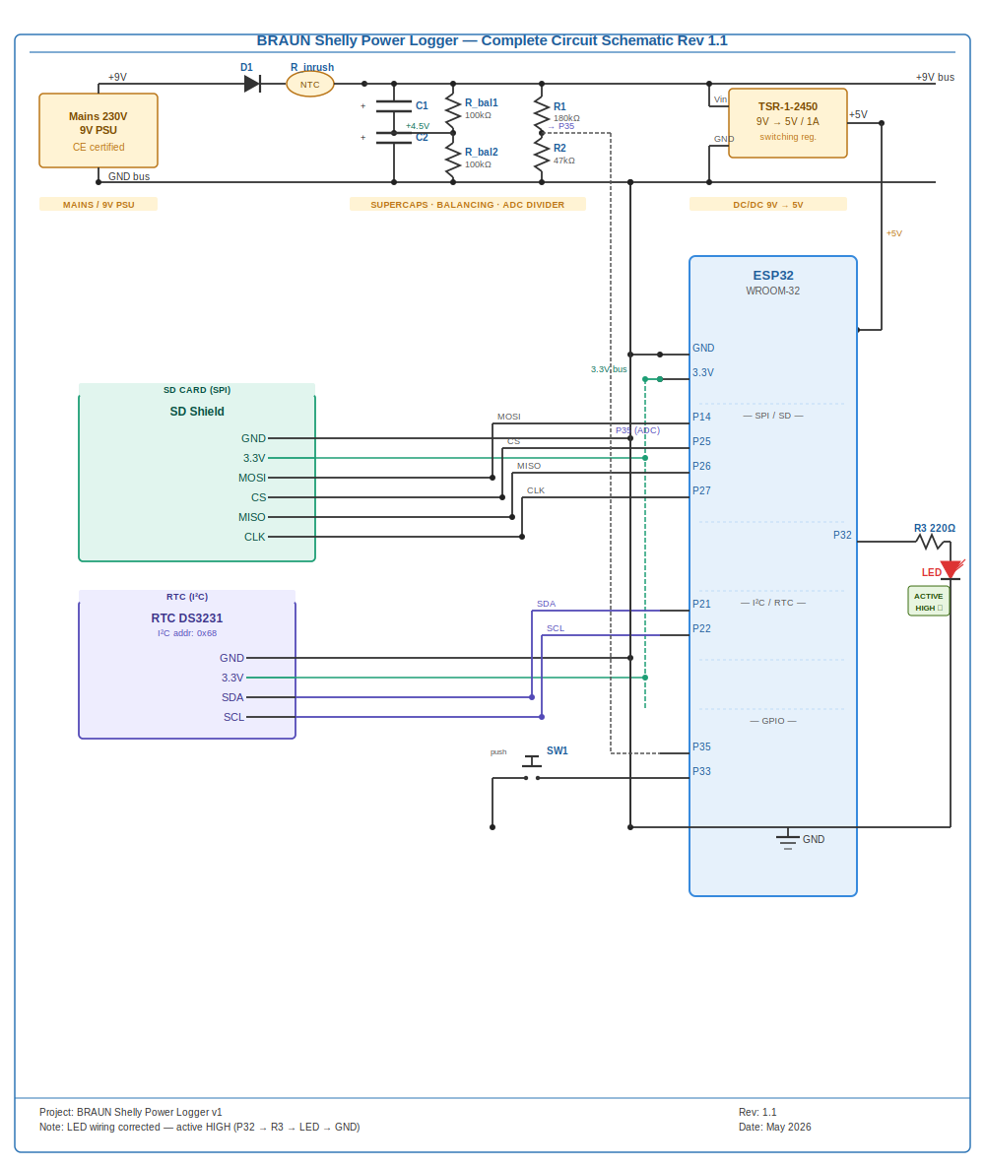
Figure 1 — Complete circuit schematic Rev 1.1. All pin labels inside component boxes. LED wiring corrected to active-HIGH (P32 → R3 220Ω → LED → GND). R1/R2 voltage divider supplies ADC on P35.

3. ESP32 Pin Assignment
The table and diagram below document every GPIO used in this design. GPIOs 16 and 17 were used for the PZEM UART in the previous hardware revision; they are now free after the switch to the wireless Shelly sensor.

3.1 Pin assignment diagram
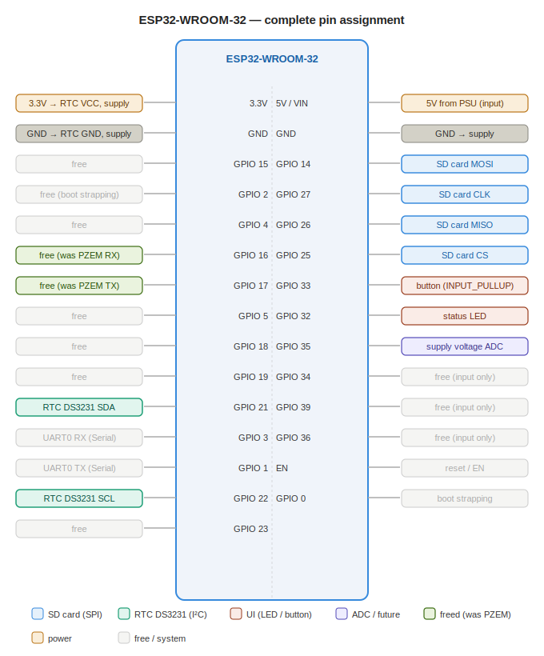
Figure 2 — ESP32-WROOM-32 complete GPIO assignment. Faded entries are unconnected.

3.2 Pin assignment table
GPIO / Pin | Connected to | Category
3.3V | RTC VCC + board supply rail | Power
GND | RTC GND + board ground | Power
5V / VIN | 5 V input from PSU | Power
GPIO 14 | SD card MOSI (SPI VSPI) | SD SPI
GPIO 25 | SD card CS | SD SPI
GPIO 26 | SD card MISO (SPI VSPI) | SD SPI
GPIO 27 | SD card CLK (SPI VSPI) | SD SPI
GPIO 21 | RTC DS3231 SDA (I²C) | RTC I2C
GPIO 22 | RTC DS3231 SCL (I²C) | RTC I2C
GPIO 32 | Status LED (output) | UI
GPIO 33 | Reset button (INPUT_PULLUP) | UI
GPIO 35 | Supply voltage ADC (input only) | ADC
GPIO 16 | Free | Free
GPIO 17 | Free | Free
GPIO 1 | UART0 TX (Serial / debug) | System
GPIO 3 | UART0 RX (Serial / debug) | System
GPIO 0 | Boot strapping — do not drive | System
GPIO 2 | Boot strapping — do not drive | System
GPIO 15 | Free | Free
GPIO 4 | Free | Free
GPIO 5 | Free | Free
GPIO 18 | Free | Free
GPIO 19 | Free | Free
GPIO 23 | Free | Free
GPIO 34 | Free (input only, no pull) | Free
GPIO 36 | Free (input only, no pull) | Free
GPIO 39 | Free (input only, no pull) | Free

4. DS3231 RTC Wiring
The DS3231 ZS042 module connects to the ESP32 via the hardware I²C bus (Wire bus 0). GPIO 21 and GPIO 22 are the dedicated SDA and SCL pins on the ESP32-WROOM-32 and include internal pull-up support.

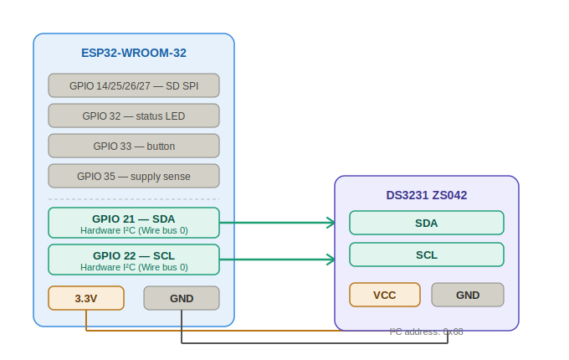
Figure 3 — DS3231 ZS042 to ESP32 wiring. All signals are 3.3 V logic.

4.1 Connection table
DS3231 pin | ESP32 pin | Signal | Notes
SDA | GPIO 21 | I²C data | 4.7 kΩ pull-up recommended
SCL | GPIO 22 | I²C clock | 4.7 kΩ pull-up recommended
VCC | 3.3V | Power | Do NOT connect to 5V
GND | GND | Ground
32K | — | 32 kHz output | Leave unconnected if unused
SQW | — | Square wave / INT | Leave unconnected if unused

4.2 Battery note (ZS042 module)
Many ZS042 boards include a trickle-charging circuit intended for LIR2032 rechargeable cells. If a non-rechargeable CR2032 is installed, the charging resistor (R1, typically 200 Ω) must be removed or the VCC→BAT trace cut to prevent overcharging.

5. Supercapacitor Balancing (Optional)
If two supercapacitors are stacked in series across the 9 V supply rail, passive balancing resistors are required to equalise the voltage across each cell and prevent either from exceeding its rated voltage.

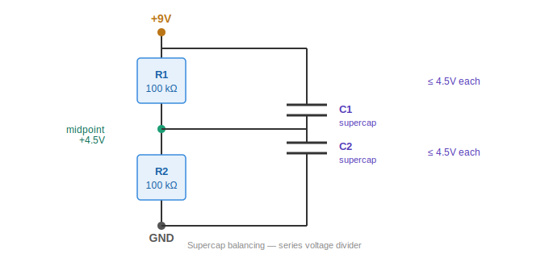
Figure 4 — Series supercap stack with passive balancing resistors R1 and R2.

5.1 How it works
R1 (100 kΩ) connects from the positive supply rail (+9 V) down to the midpoint — the junction between C1 and C2. R2 (100 kΩ) connects from the midpoint down to GND. Together, R1 and R2 form a voltage divider that forces the midpoint to +4.5 V, so each capacitor sees at most half the supply voltage regardless of individual leakage mismatch.

5.2 Design values
Parameter | Value | Formula | Notes
Supply voltage | 9 V | — | Across C1 + C2 in series
Voltage per cap | 4.5 V | 9 V / 2 | Must be ≤ cap voltage rating
R1 = R2 | 100 kΩ | Equal divider | Higher R = lower bleed current
Bleed current | ≈90 μA | 9V / 100kΩ | Negligible power loss
Power in R1/R2 | ≈0.4 mW each | V²/R | 4.5²/100k

Important: Verify the individual capacitor voltage rating before powering up. Common coin-type supercaps are rated 2.7 V — a 2S stack at 9 V would overvolt them. Use capacitors rated ≥ 5 V per cell, or reduce the supply voltage accordingly.

6. Firmware Module Overview
File | Responsibility
Config.h | All pin definitions, timing constants, Wi-Fi credentials, SD path
ShellyClient.h | Receives and validates JSON push from Shelly; watchdog timer
Logger.h | RAM ring buffer, SD card writes, poll scheduling, power threshold
WebPortal.h/.cpp | HTTP server, all web pages and API endpoints, captive portal, mDNS
StatusLed.h | Non-blocking LED blink — 1 Hz OK, 5 Hz error
shelly_push.js | Runs ON the Shelly device; reads meter and POSTs JSON every 1 s
Shelly_ESP32_Logger.ino | Main sketch: object instantiation, setup(), loop()

6.1 Required Arduino libraries
- ArduinoJson by Benoit Blanchon (≥ v6.x) — JSON parse/serialise
- RTClib by Adafruit — DS3231 driver
- SD (built-in ESP32 core)
- WiFi, WebServer, ESPmDNS, DNSServer (built-in ESP32 core)

End of document

